online shopping system unified modelling language uml diagram

use case diagram of online shopping system

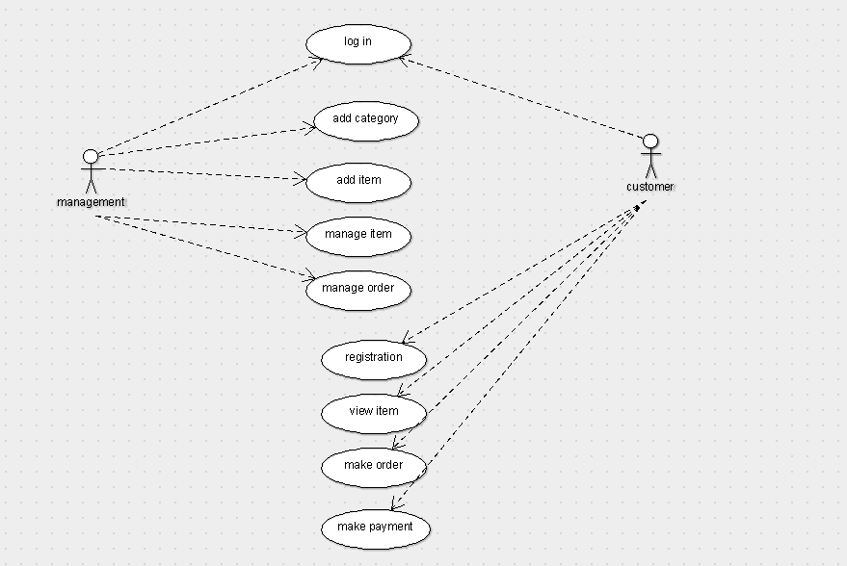

Class diagram of online shopping system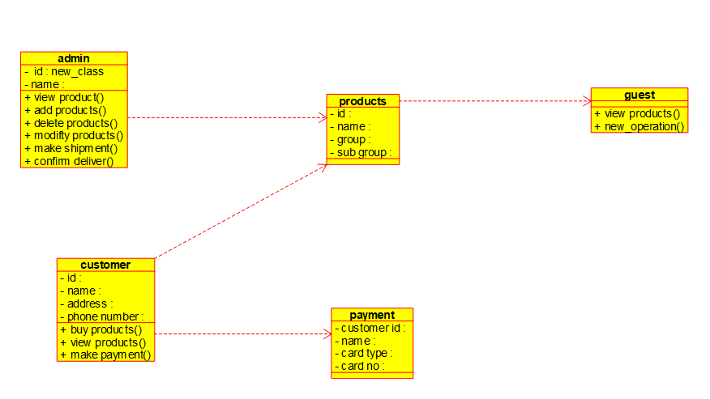

Activity diagram of online shopping system

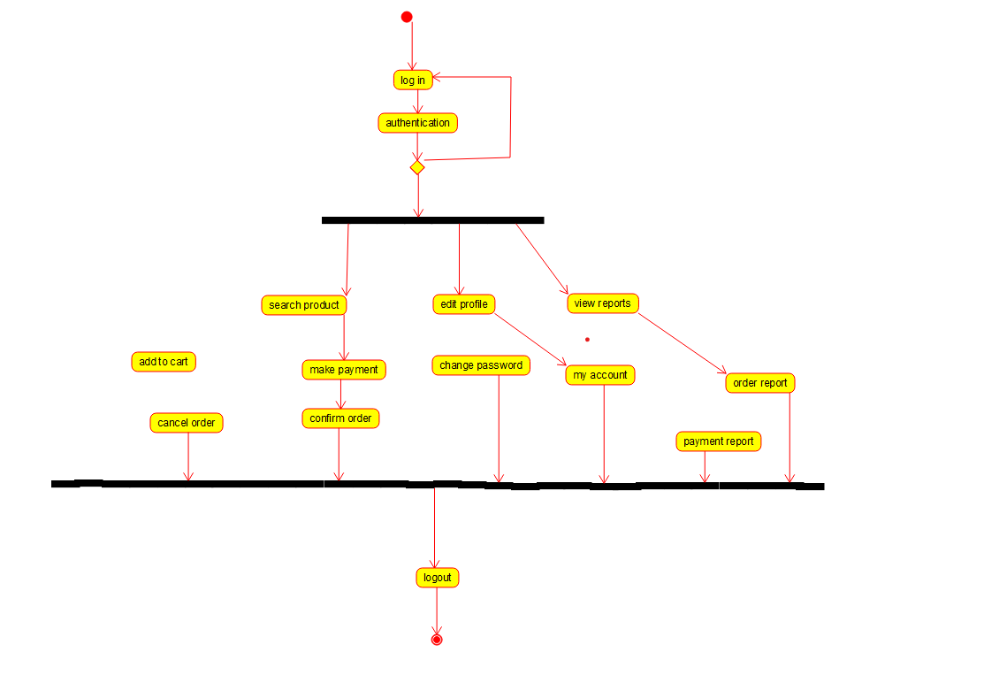

Deployment diagram of online shopping system

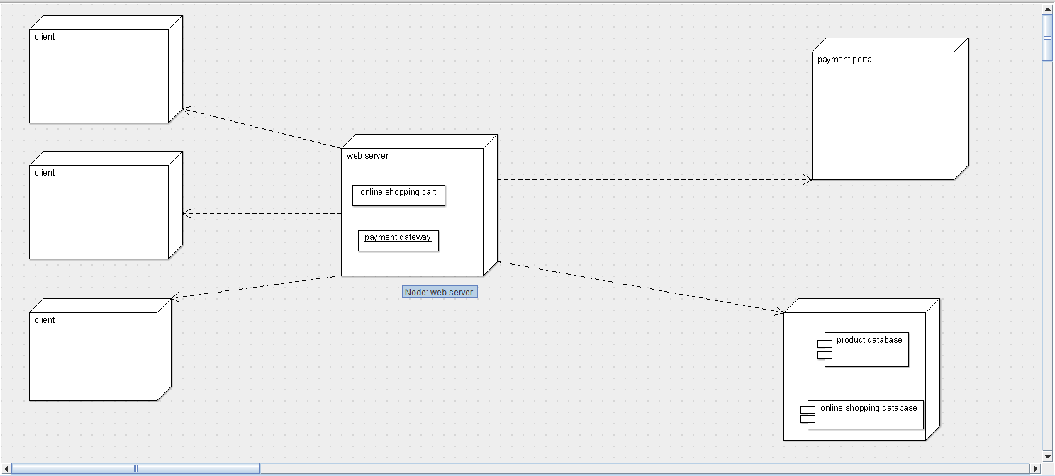

Component diagram of online shopping system

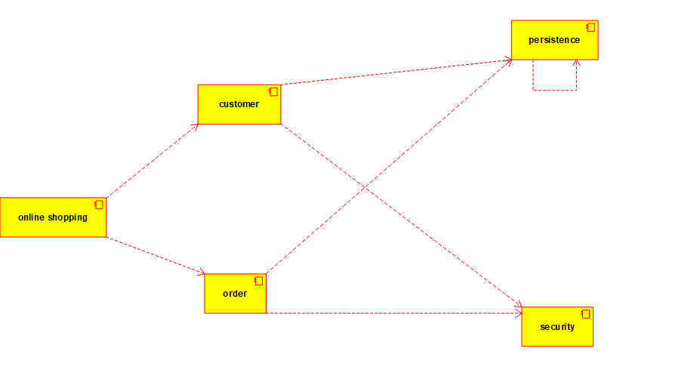

Sequence diagram of online shopping system

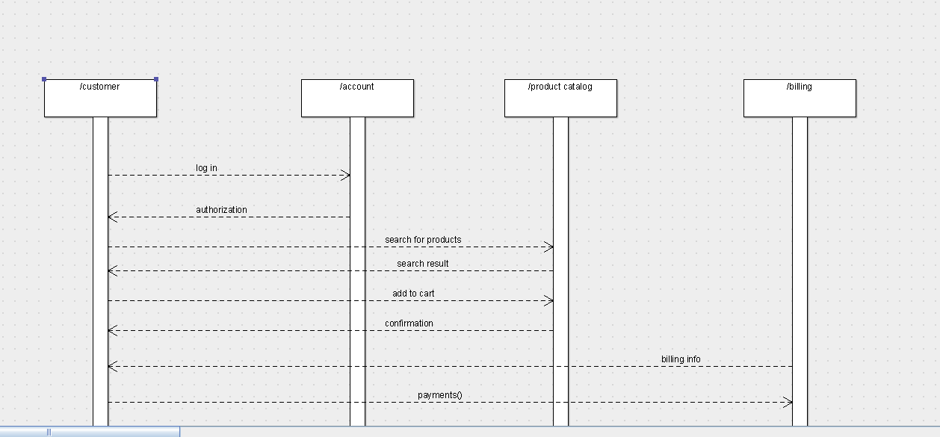

State chart diagram of online shopping system

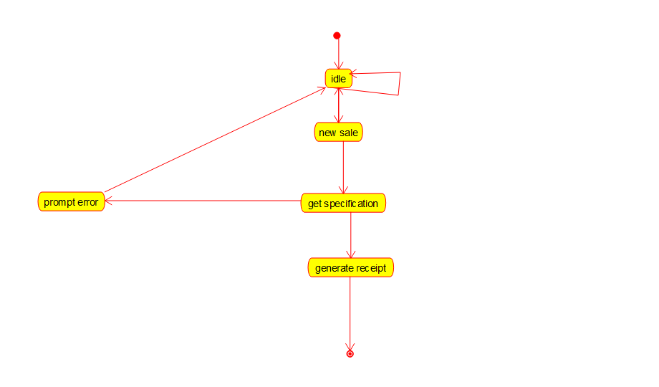

Coding for online shopping system

Admin code

/**

* Class admin

*/

public class admin {

//

// Fields

//

private void id;

private void name;

//

// Constructors

//

public admin () { };

//

// Methods

//

//

// Accessor methods

//

/**

* Set the value of id

* @param newVar the new value of id

*/

private void setId (void newVar) {

id = newVar;

}

/**

* Get the value of id

* @return the value of id

*/

private void getId () {

return id;

}

/**

* Set the value of name

* @param newVar the new value of name

*/

private void setName (void newVar) {

name = newVar;

}

/**

* Get the value of name

* @return the value of name

*/

private void getName () {

return name;

}

//

// Other methods

//

/**

*/

public void view_product()

{

}

/**

*/

public void add_products()

{

}

/**

*/

public void delete_products()

{

}

/**

*/

public void modify_products()

{

}

/**

*/

public void make_shipment()

{

}

/**

*/

public void comfirm_deliver()

{

}

Customer code :-

/**

* Class admin

*/

public class admin {

//

// Fields

//

private void id;

private void name;

//

// Constructors

//

public admin () { };

//

// Methods

//

//

// Accessor methods

//

/**

* Set the value of id

* @param newVar the new value of id

*/

private void setId (void newVar) {

id = newVar;

}

/**

* Get the value of id

* @return the value of id

*/

private void getId () {

return id;

}

/**

* Set the value of name

* @param newVar the new value of name

*/

private void setName (void newVar) {

name = newVar;

}

/**

* Get the value of name

* @return the value of name

*/

private void getName () {

return name;

}

//

// Other methods

//

/**

*/

public void view_product()

{

}

/**

*/

public void add_products()

{

}

/**

*/

public void delete_products()

{

}

/**

*/

public void modify_products()

{

}

/**

*/

public void make_shipment()

{

}

/**

*/

public void comfirm_deliver()

{

}

Guest code

/**

* Class guest

*/

public class guest {

//

// Fields

//

//

// Constructors

//

public guest () { };

//

// Methods

//

//

// Accessor methods

//

//

// Other methods

//

/**

*/

public void view_products()

{

}

/**

*/

public void new_operation()

{

}

}

Payment code

/**

* Class payment

*/

public class payment {

//

// Fields

//

private void customer_id;

private void name;

private void card_type;

private void card_no;

//

// Constructors

//

public payment () { };

//

// Methods

//

//

// Accessor methods

//

/**

* Set the value of customer_id

* @param newVar the new value of customer_id

*/

private void setCustomer_id (void newVar) {

customer_id = newVar;

}

/**

* Get the value of customer_id

* @return the value of customer_id

*/

private void getCustomer_id () {

return customer_id;

}

/**

* Set the value of name

* @param newVar the new value of name

*/

private void setName (void newVar) {

name = newVar;

}

/**

* Get the value of name

* @return the value of name

*/

private void getName () {

return name;

}

/**

* Set the value of card_type

* @param newVar the new value of card_type

*/

private void setCard_type (void newVar) {

card_type = newVar;

}

/**

* Get the value of card_type

* @return the value of card_type

*/

private void getCard_type () {

return card_type;

}

/**

* Set the value of card_no

* @param newVar the new value of card_no

*/

private void setCard_no (void newVar) {

card_no = newVar;

}

/**

* Get the value of card_no

* @return the value of card_no

*/

private void getCard_no () {

return card_no;

}

//

// Other methods

//

}

Payment code

/**

* Class products

*/

public class products {

//

// Fields

//

private void id;

private void name;

private void group;

private void sub_group;

//

// Constructors

//

public products () { };

//

// Methods

//

//

// Accessor methods

//

/**

* Set the value of id

* @param newVar the new value of id

*/

private void setId (void newVar) {

id = newVar;

}

/**

* Get the value of id

* @return the value of id

*/

private void getId () {

return id;

}

/**

* Set the value of name

* @param newVar the new value of name

*/

private void setName (void newVar) {

name = newVar;

}

/**

* Get the value of name

* @return the value of name

*/

private void getName () {

return name;

}

/**

* Set the value of group

* @param newVar the new value of group

*/

private void setGroup (void newVar) {

group = newVar;

}

/**

* Get the value of group

* @return the value of group

*/

private void getGroup () {

return group;

}

/**

* Set the value of sub_group

* @param newVar the new value of sub_group

*/

private void setSub_group (void newVar) {

sub_group = newVar;

}

/**

* Get the value of sub_group

* @return the value of sub_group

*/

private void getSub_group () {

return sub_group;

}

//

// Other methods

//

}